**DAILY ONLINE ACTIVITIES SUMMARY**

|  |  |  |  |  |  |  |  |  |
| --- | --- | --- | --- | --- | --- | --- | --- | --- |
| **Date:** | **5/6/2020** | | | | | **Name:** | **Banish M G** | |
| **Sem & Sec** | **8th Sem** | | | | | **USN:** | **4AL16CS020** | |
| **Online Test Summary** | | | | | | | | |
| **Subject** | | **BDA** | | | | | | |
| **Max. Marks** | | **30** | | **Score** | | | **25** | |
| **Certification Course Summary** | | | | | | | | |
| **Course** | **Python for data science** | | | | | | | |
| **Certificate Provider** | | | **udemy** | | **Duration** | | | **23 hrs** |
| **Coding Challenges** | | | | | | | | |
| **Problem Statement:**  1. Write a Python program to convert seconds today, hour, minutes and seconds | | | | | | | | |
| **Status:COMPLETED** | | | | | | | | |
| **Uploaded the report in Github** | | | | | **yes** | | | |
| **If yes Repository name** | | | | | B**anish_MG** | | | |
| **Uploaded the report in slack** | | | | | **yes** | | | |

Online Test Details: (Attach the snapshot and briefly write the report for the same)

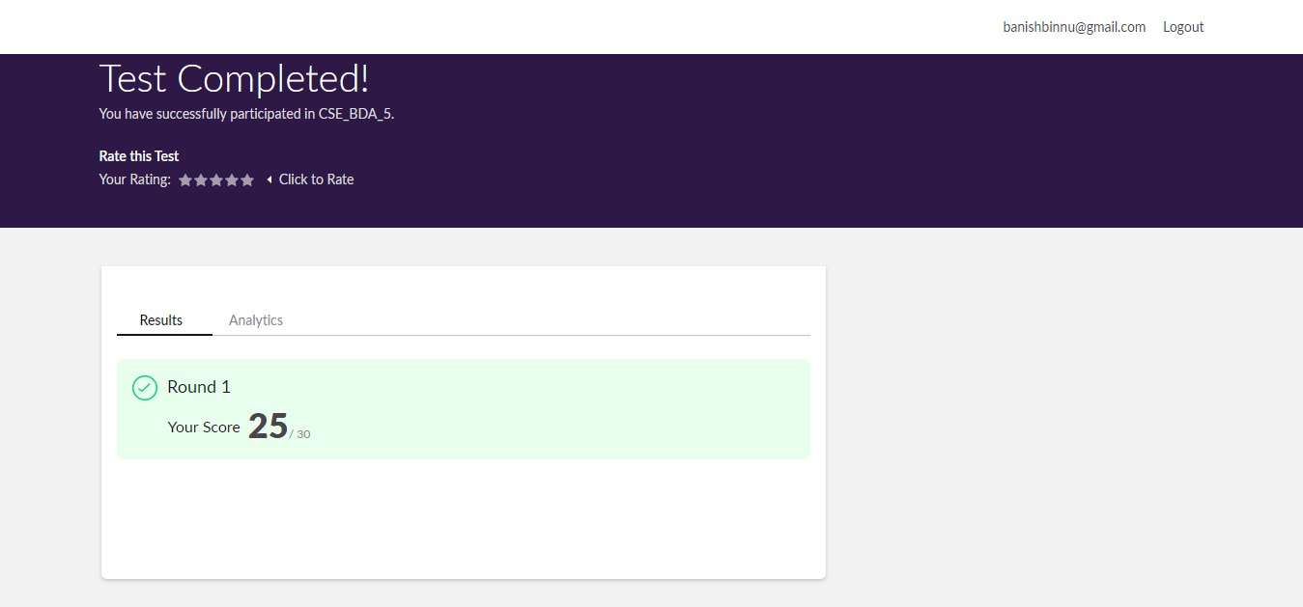

Certification Course Details: (Attach the snapshot and briefly write the report for the same)

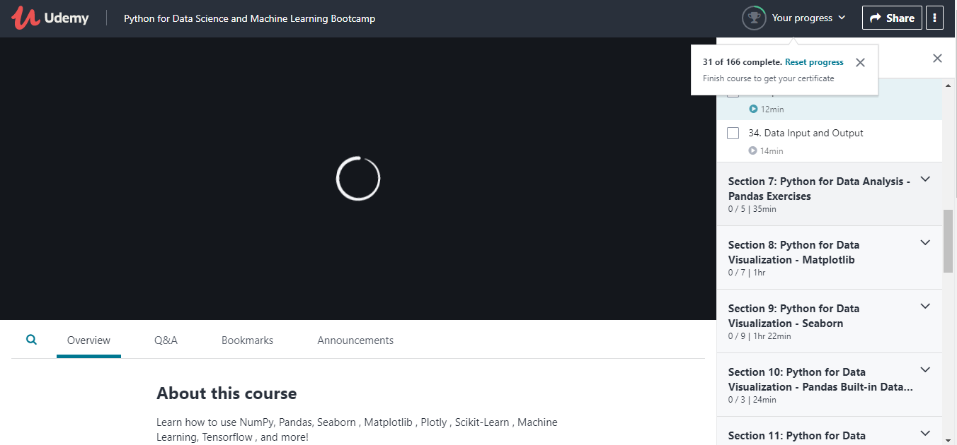

Coding Challenges Details: (Attach the snapshot and briefly write the report for the same)

Write a Python program to convert seconds today, hour, minutes and seconds

time=float(input("Inputimeinseconds:"))

day=time /(24*3600)time=time%(24*3600)

hour=time/3600 time%=3600

minutes=time /60time%=60

seconds=timeprint("day:->%d"%(day) print("hour:->%d"%(hour) print("minutes:->%d"%(minutes) print("seconds:->%d"%(seconds)